**Introduction:** Welcome to the introduction of Memfull, your ultimate travel companion designed to revolutionize the way you explore the world. Memfull is a cutting-edge platform that simplifies travel planning by providing personalized recommendations and detailed insights on must-visit locations near you.

**Problem:**

We created the Memfull website to address the challenges faced by myself and fellow travel enthusiasts in discovering new places to explore and finding the best routes to reach them. Often, we found ourselves scrolling through countless YouTube videos and other resources just to gather basic information. Memfull streamlines this process by offering a centralized platform that provides personalized travel recommendations and detailed route information, making travel planning simpler and more efficient.

**Solution:**

The Memfull team has created a centralized platform where travelers who have visited various places can contribute detailed information and routes into the Memfull database. This wealth of user-generated content empowers other explorers to efficiently plan their trips, with comprehensive insights and accurate directions at their fingertips. By leveraging these shared experiences, users can make informed decisions and accurately budget their adventures, ensuring a well-planned and enjoyable travel experience for everyone.

**Key features:**

Contribution: We have facilitated the users to contribute their knowledge into our database which is again used by the other explorers to find the places and comfortably place and explore the place.(add the picture of the contribution page)

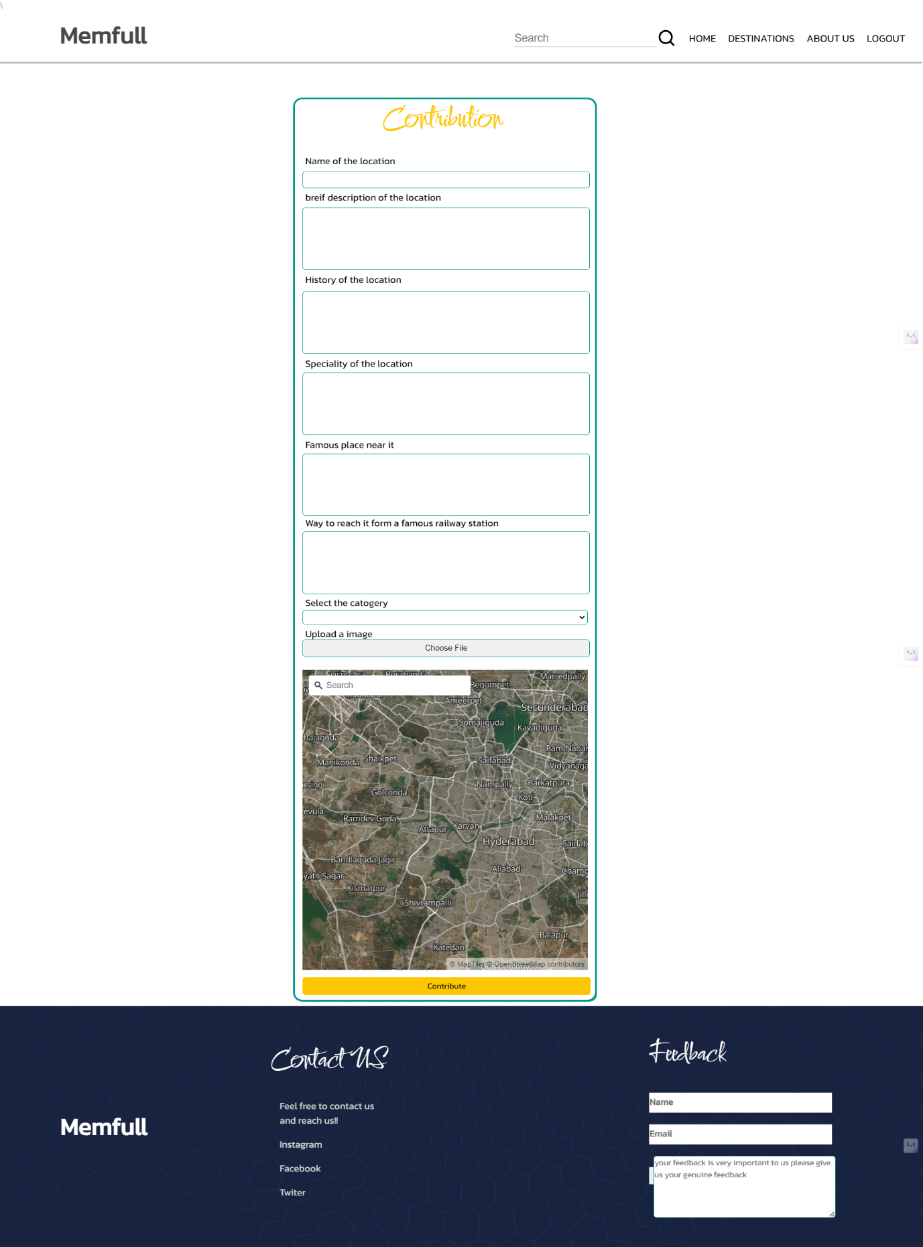

Shared the experience :We have facilitated the user to share the experiences faced by them through the comment box so, that the other travellers can experience the glimpse of the happiness of explore that place.

And provided the facility of uploading the pictures in to the website to show their experiences.(add the below image to this feature)

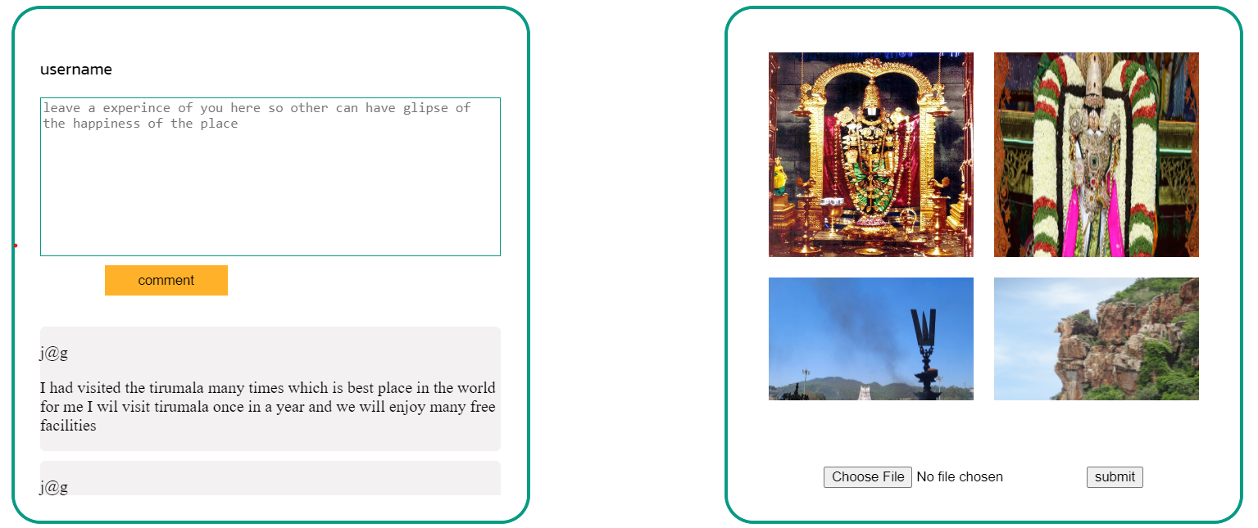

Geolocation: We all know that just by knowing the address we can pin the perfect point on the map and calculate the distance and other parameters so, we also provide the geo-coordinates to the place so, that the user can get pin point location details and it so easy to the traveller to track them in the route if they have the geo location.(add this image to this feature and write)

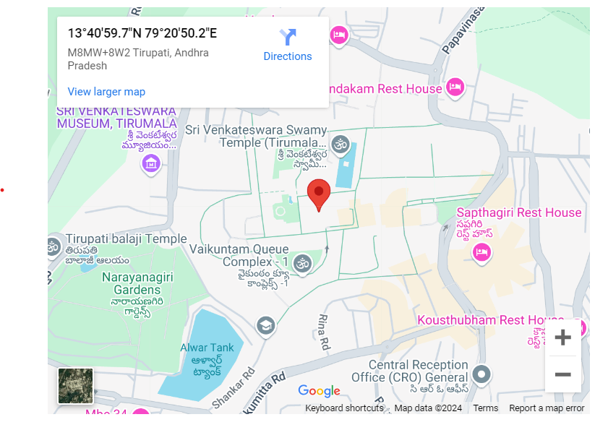

A geo location to Sri Venkateswara Swamy Temple in Tirumala.